16.71: a)

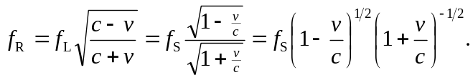

b) For small x, the binomial theorem (see Appendix B) gives 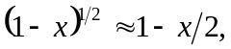
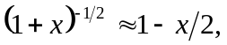 so

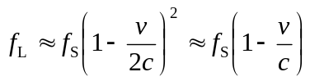

where the binomial theorem has been used to approximate 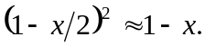

The above result may be obtained without resort to the binomial theorem by expressing 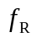 in terms of 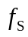as

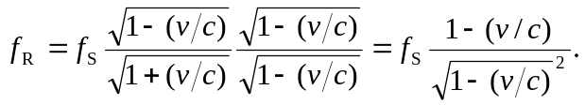

To first order in 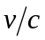, the square root in the denominator is 1, and the previous result is obtained. c) For an airplane, the approximation is certainly valid, and solving the expression found in part (b) for 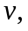

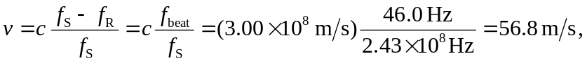

and the approximation is seen to be valid. Note that in this case, the frequency difference is known to three figures, so the speed of the plane is known to three figures.

